

PROJECT REPORT
COURSE CODE :24ADI204
COURSE TITLE :DATA SCIENCE AND VISUALIZATION

CREDIT CARD FRAUD DETECTION

SUBMITTED BY
DIVYADHARSHINI S(24BAD022)
JOHIYA SRI S(24BAD050)
KARTHIK SARAVANAKUMAR M(24BAD056)
ARUN PR(24BAD012)

DEPARTMENT OF ARTIFICIAL INTELLIGENCE AND DATA SCIENCE
KUMARAGURU COLLEGE OF TECHNOLOGY
( Autonomous Institution )
COIMBATORE – 641 049

INTRODUCTION :
The rapid growth of digital payment systems and online banking has significantly increased the use of credit cards worldwide. While these technologies offer convenience and efficiency, they also create opportunities for fraudulent activities. Credit card fraud has become a major concern for financial institutions as it can lead to financial losses and reduced customer trust.
Detecting fraudulent transactions is challenging because they represent only a small fraction of total transactions, resulting in highly imbalanced datasets. This project analyzes credit card transaction data using data science techniques such as data preprocessing, exploratory data analysis (EDA), and Principal Component Analysis (PCA) to identify patterns and detect potential fraudulent activities.

DOMAIN :
Finance, Banking, and Financial Technology (FinTech)
This project belongs to the financial and banking domain, where credit cards are widely used for digital transactions. Financial institutions process a large volume of transactions daily, making it essential to detect and prevent fraudulent activities.
Data science and machine learning techniques help analyze transaction patterns such as transaction amount, time, and behavioral trends to distinguish between legitimate and fraudulent transactions. Effective fraud detection systems help reduce financial losses and improve the security of digital payment systems.

PROBLEM STATEMENT :
Credit Card Fraud Detection
Credit card fraud detection is a major challenge in the banking and financial sector due to the highly imbalanced nature of transaction data. Fraudulent transactions represent only a small fraction of the total transactions, making them difficult to detect using traditional analytical methods. As digital payment systems continue to grow, the risk of fraudulent activities also increases, creating a need for more effective fraud detection techniques.

PROBLEM ABSTRACT :
Credit card fraud has become a serious issue with the rapid growth of digital payments and online transactions. Since fraudulent transactions represent only a very small portion of the overall data, detecting them accurately is a challenging task.
A notable example is the 2016 Indian Debit Card Data Breach, where millions of card details were compromised, highlighting the need for stronger fraud detection systems. This project analyzes credit card transaction data using data science techniques and applies Principal Component Analysis (PCA) to reduce dimensionality and visualize transaction patterns. The approach helps identify fraudulent transactions as anomalies among legitimate ones.

OBJECTIVE :
- To analyze credit card transaction data and understand its structure and features.
- To perform data preprocessing techniques such as handling missing values and detecting outliers.
- To conduct exploratory data analysis (EDA) to identify patterns and relationships within the dataset.
- To apply dimensionality reduction techniques such as Principal Component Analysis (PCA) for better visualization and analysis.
- To identify anomalies or unusual transaction patterns that may indicate fraudulent activities.

CHALLENGES :
- Imbalanced Dataset: Fraudulent transactions represent a very small percentage of the total transactions, making it difficult to detect them accurately.
- High Volume of Transactions: Financial institutions process millions of transactions daily, which makes real-time fraud detection complex.
- Evolving Fraud Techniques: Fraudsters continuously change their methods, making it challenging for detection systems to keep up.
- Data Privacy and Security: Handling sensitive financial data requires strict privacy and security measures.
- False Positives: Incorrectly identifying legitimate transactions as fraud can affect customer experience and trust.
WEEK 1 :
TEAM FORMATION AND DATA HUNTING

TEAM NO : 5
TEAM MEMBERS :
24BAD022 - Divyadharshini S
24BAD050 - Johiya Sri S
24BAD056 - Karthik Saravanakumar M
24BAD012 - Arun P R

GITHUB LINK :
https://github.com/johiyasri/24ADI204_DSV_TEAM5.git

INTERACTIVE PYTHON NOTEBOOK :
https://www.kaggle.com/code/diviiis/dsv-team-5

ONEDRIVE LINK :
https://kumaragurudtsteam-my.sharepoint.com/:f:/g/personal/divyadharshini_24ad_kct_ac_in/IgC92cd78AGISbJtfAVjGo-8AeuuuM8J-tW_j-Oj-vCvFsA?e=Zg6yc7
DATASET :
Credit Card Transactions Fraud Detection Dataset
https://www.kaggle.com/datasets/kartik2112/fraud-detection

ABOUT DATASET:
The dataset contains approximately 1.3 million credit card transaction records with various attributes describing each transaction, such as transaction time, merchant information, transaction category, transaction amount, and customer location details. The dataset also includes a target variable is_fraud, which indicates whether a transaction is fraudulent (1) or legitimate (0). This dataset is suitable for analyzing transaction patterns and identifying fraudulent activities using data analysis techniques.

TEAM CONTRIBUTION :

TEAM MEMBER | CONTRIBUTION
DIVYADHARSHINI S | Created and organized a shared OneDrive repository to store and manage project documents and resources.
JOHIYA SRI S | Set up and maintained the GitHub repository to enable version control and collaborative development.
KARTHIK SARAVANAKUMAR M | Analyzed and interpreted the project problem statement to identify key challenges and objectives.
ARUN P R | Explored and analyzed the selected dataset on Kaggle to understand its structure, features, and relevance to the project.

WEEK 2 :
KNOW YOUR DATA

OBJECTIVE :
The objective is to gain an initial understanding of the dataset before performing further analysis. This involved loading the dataset into the Python environment, examining its structure, identifying data types, and generating a preliminary overview of the data.

USED PACKAGES AND METHODS :
PACKAGEs : pandas
METHODS : head(), tail(), info(), describe(), isnull(), sum()

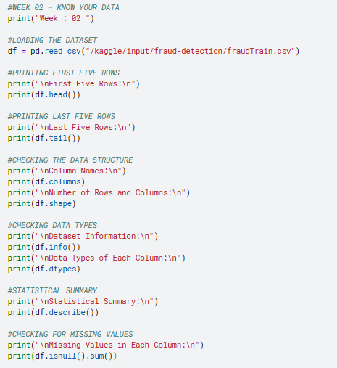

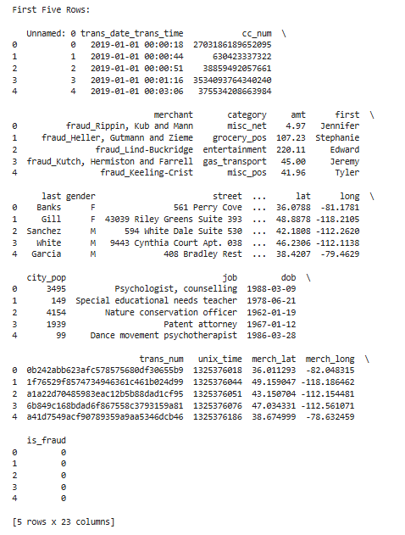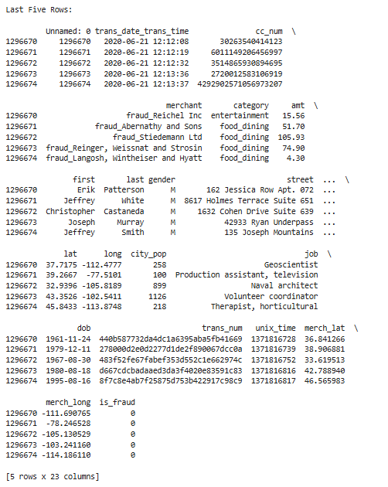

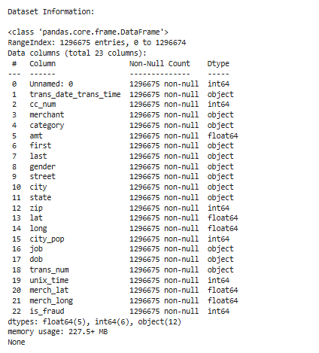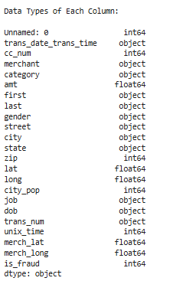
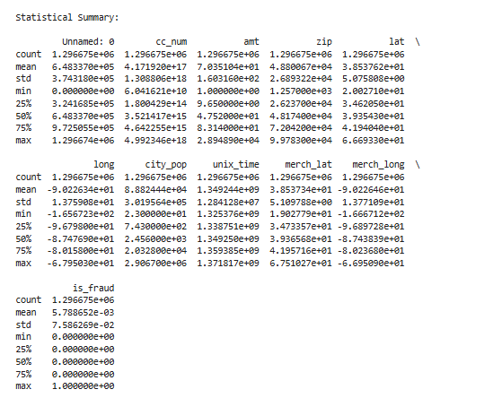
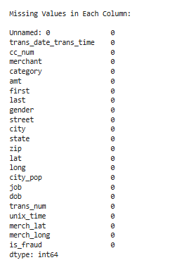

INTERPRETATION :
- The dataset contains 1,296,675 transaction records with 23 attributes, indicating a large dataset suitable for fraud detection analysis.
- The dataset includes a mix of numerical attributes (such as amt, city_pop, lat, long, unix_time) and categorical attributes (such as merchant, category, gender, city, and job). This combination provides detailed information about both transaction characteristics and customer demographics.
- The statistical summary shows that the average transaction amount is approximately 70.35, while the maximum transaction amount is significantly higher, indicating the presence of high-value transactions that may require further analysis.
- The target variable is_fraud contains values 0 and 1, where 0 represents legitimate transactions and 1 represents fraudulent transactions. The mean value of this column is very low (around 0.0057), which indicates that fraudulent transactions form only a small proportion of the dataset, highlighting the class imbalance problem.
- The dataset inspection also shows that no missing values are present in any of the columns, indicating that the dataset is complete and suitable for further preprocessing and analysis.

TEAM CONTRIBUTION :
TEAM MEMBER | CONTRIBUTION
DIVYADHARSHINI S | Implemented the Python code to load the dataset and perform the initial data inspection.
JOHIYA SRI S | Prepared the documentation and recorded the weekly progress for the project report.
KARTHIK SARAVANAKUMAR M | Analyzed the dataset attributes and interpreted the statistical summary generated from the data.
ARUN P R | Verified the data types of the attributes and examined the dataset for missing values.
WEEK 3 :
THE CLEANING SPRINT
OBJECTIVE :
To improve the data quality of the dataset by identifying and handling missing values and detecting outliers. Data cleaning is an important preprocessing step that ensures the dataset is reliable and suitable for further analysis and model building. This stage focuses on applying imputation techniques to handle missing values and statistical methods to detect outliers in the transaction amount feature.

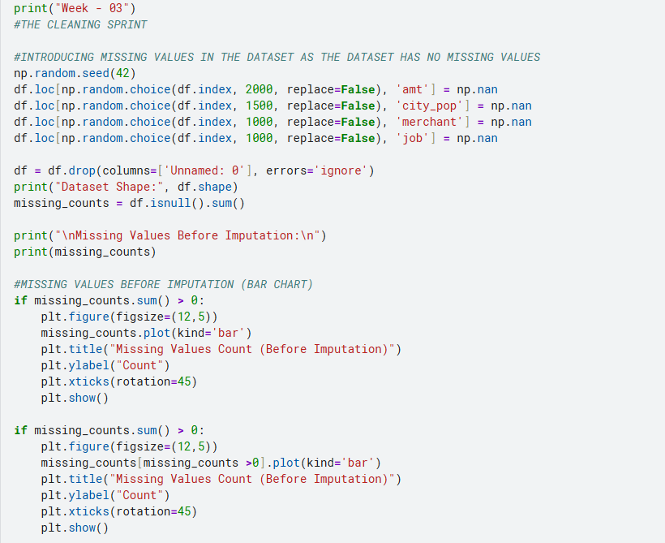

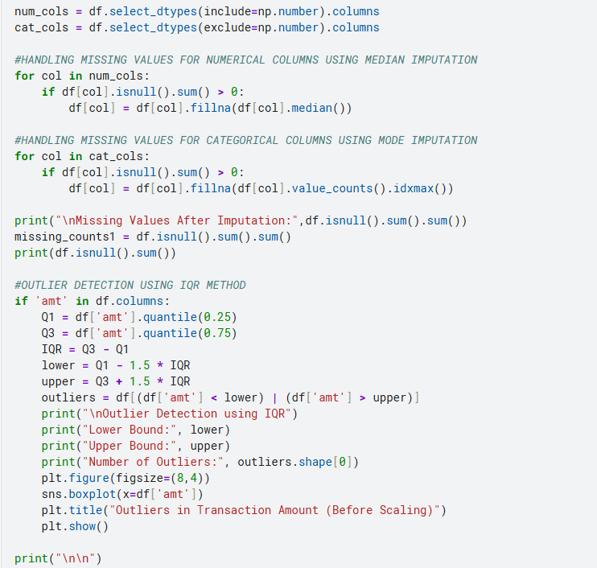
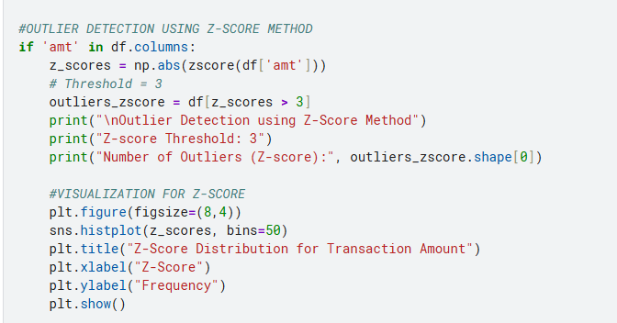
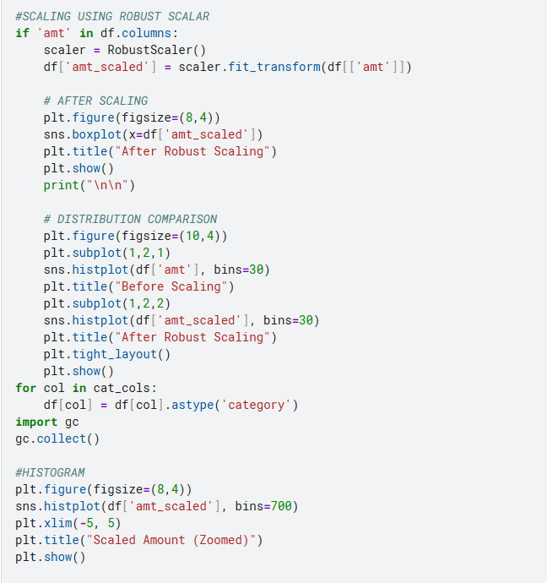
OUTPUT :
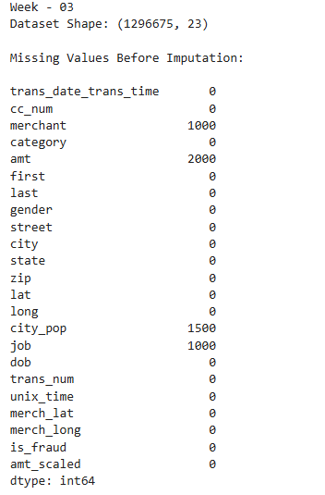
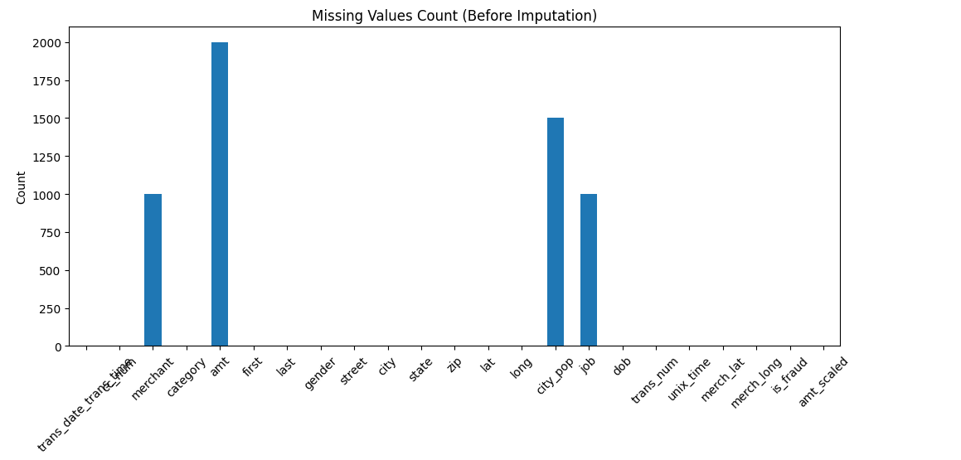
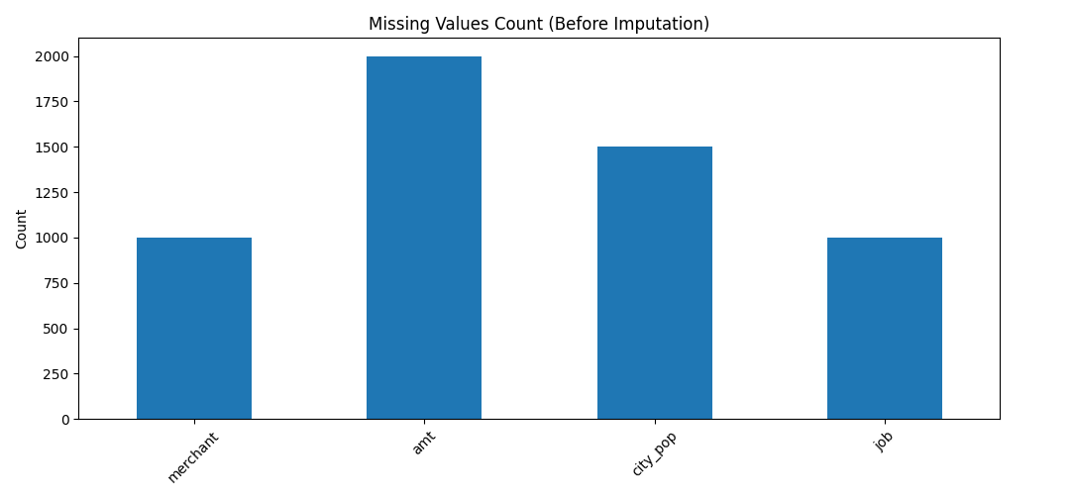
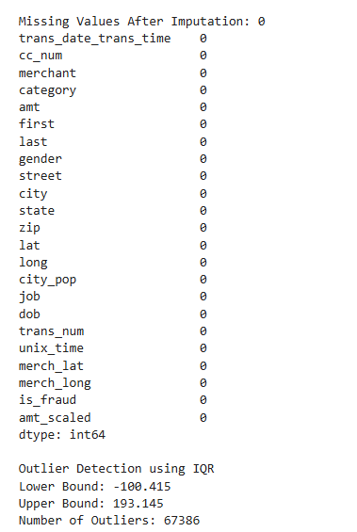
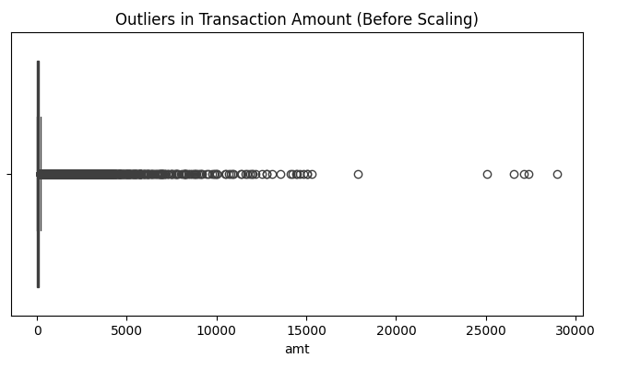
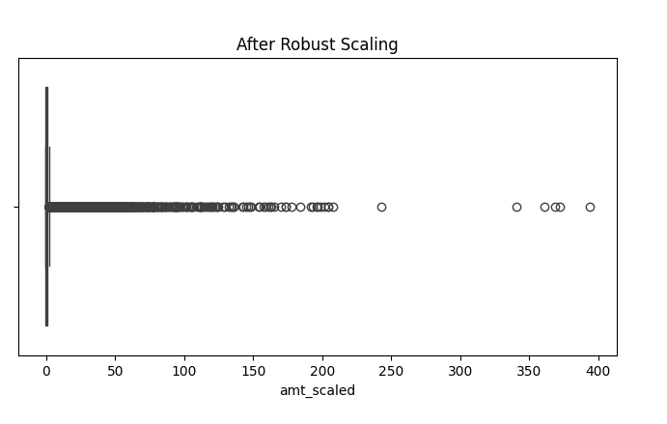
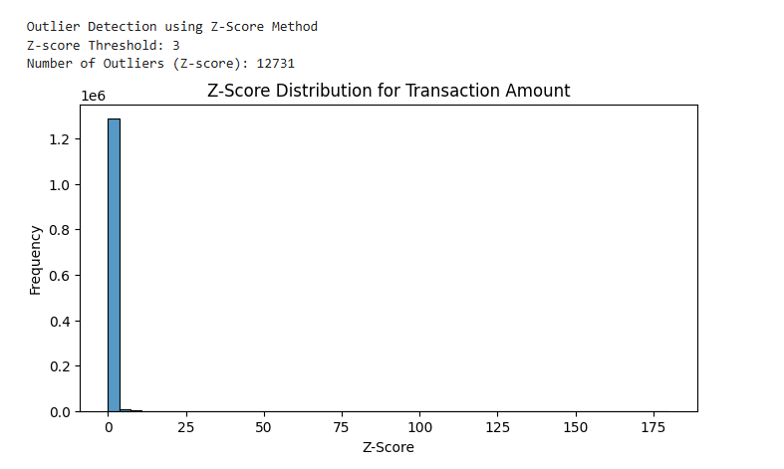
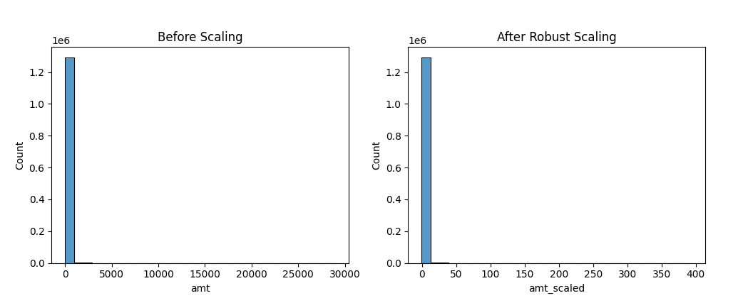
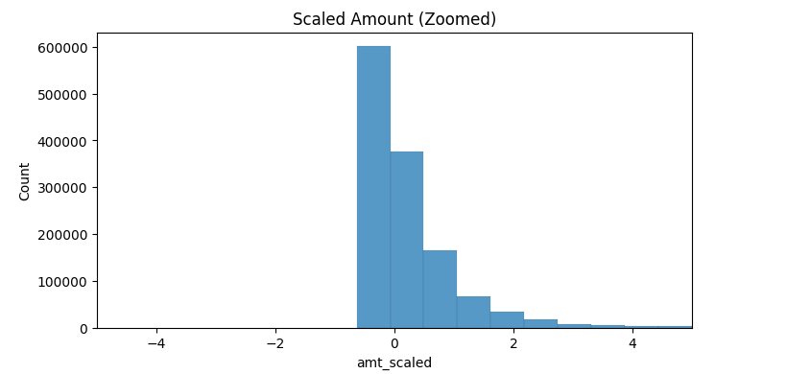

INTERPRETATION :
- Missing values were intentionally introduced into selected columns (amt, city_pop, merchant, and job) to demonstrate data cleaning techniques. A total of 5,500 missing values were identified in the dataset.
- Median imputation was applied to numerical features such as amt and city_pop, while mode imputation was applied to categorical features such as merchant and job. After applying these imputation strategies, all missing values were successfully removed from the dataset.
- Outlier detection using the Interquartile Range (IQR) method revealed that the transaction amount feature contains 67,386 outliers. The calculated lower and upper bounds were −100.415 and 193.145, respectively. These results indicate that many transactions have values significantly higher than the normal spending range.
- Outlier detection using the Z-Score method was also performed to measure how far each transaction amount deviates from the mean in terms of standard deviations. Transactions with a Z-Score greater than ±3 were classified as outliers. This method provided an additional statistical validation for identifying extreme values.
- The presence of these extreme values suggests that certain transactions are unusually large compared to typical spending behavior, which may indicate rare high-value purchases or potentially fraudulent activities.
- Visualization techniques such as boxplots and distribution plots helped in clearly identifying the spread of transaction amounts and the presence of extreme values.
- To reduce the impact of these outliers on further analysis, Robust Scaling was applied to the amt column. This technique uses the median and interquartile range, making it effective for datasets containing extreme values.
- The cleaned and scaled dataset is now more reliable and suitable for further preprocessing, feature engineering, and machine learning model development for fraud detection.

TEAM CONTRIBUTION :

TEAM MEMBER | CONTRIBUTION
DIVYADHARSHINI S | Implemented missing value handling techniques, performed data imputation, and completed the documentation work for Week-3.
JOHIYA SRI S | Generated visualizations and analyzed outliers using boxplots.
KARTHIK SARAVANAKUMAR M | Performed statistical outlier detection using the IQR method and interpreted the results.
ARUN P R | Reviewed the cleaned dataset and verified the preprocessing results after handling missing values and outliers.

WEEK 4:
EDA DEEP DIVE
OBJECTIVE:
To perform an in-depth Exploratory Data Analysis (EDA) by understanding and analyzing both univariate and bivariate data. The objective includes summarizing data characteristics, identifying patterns, trends, and outliers, and effectively visualizing distributions using appropriate graphical techniques to gain meaningful insights from the dataset.
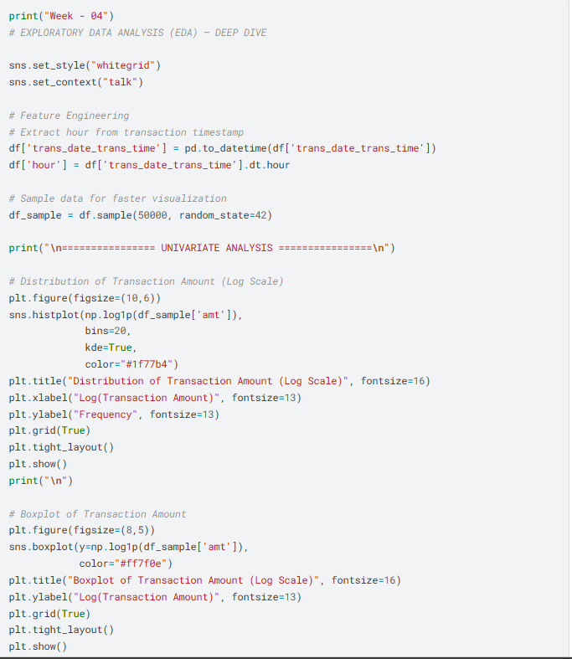

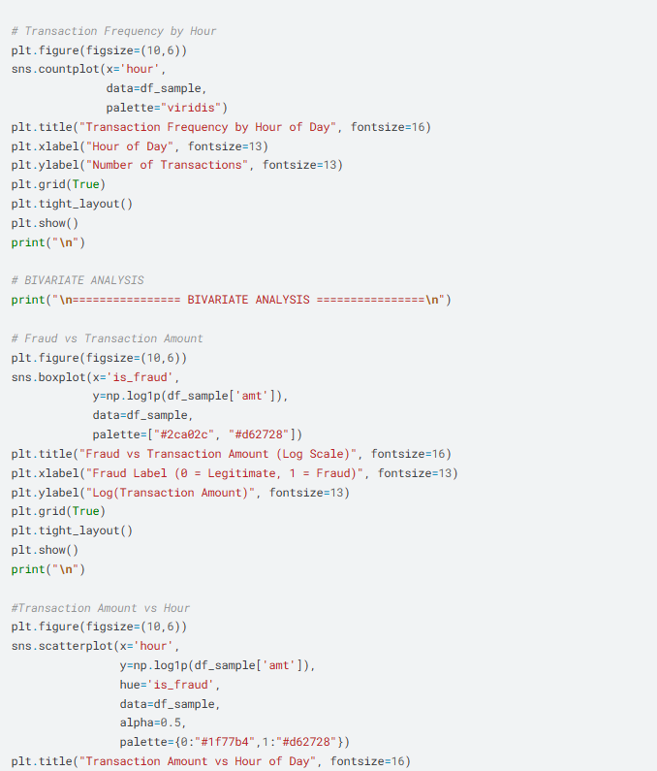
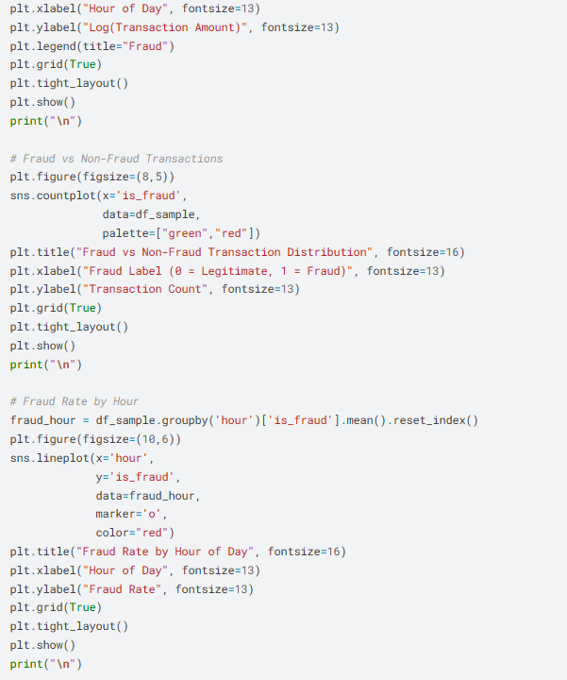
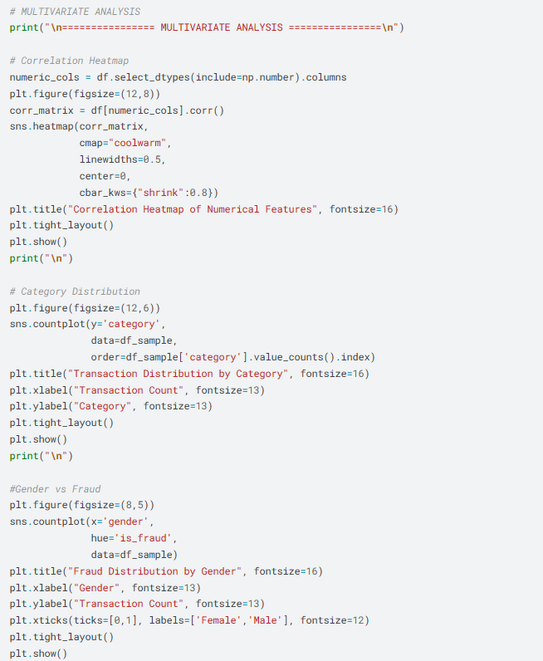
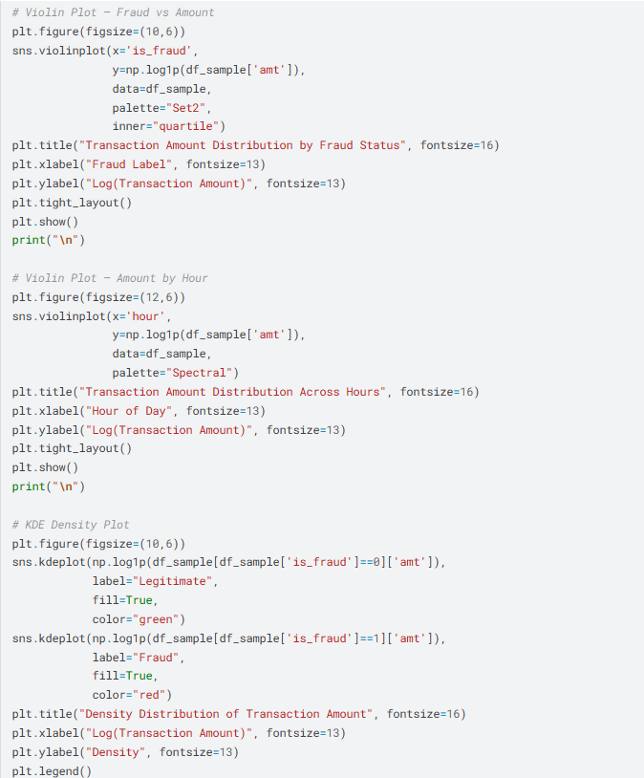
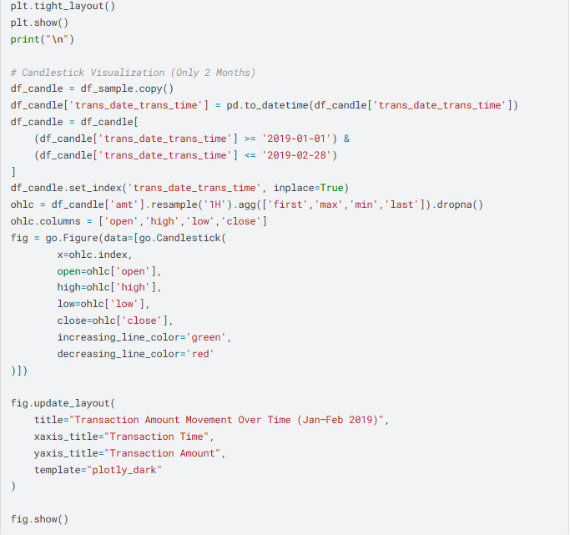
OUTPUT:

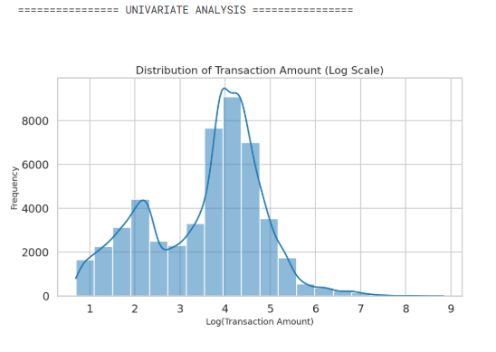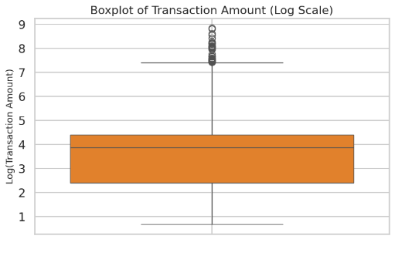
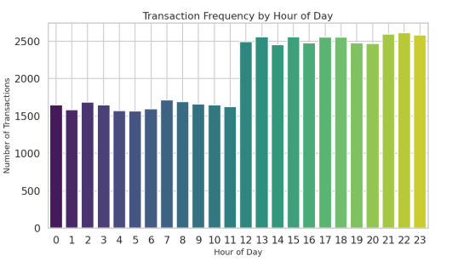
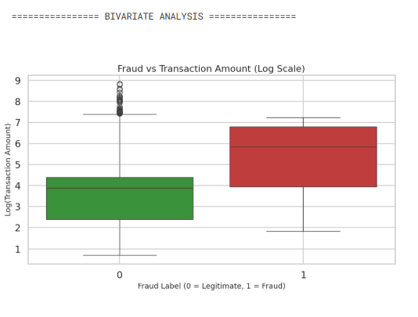
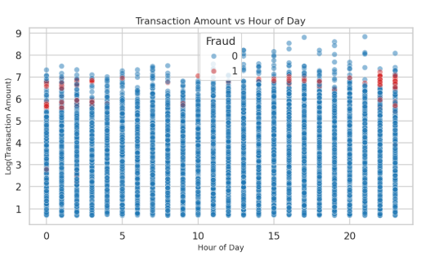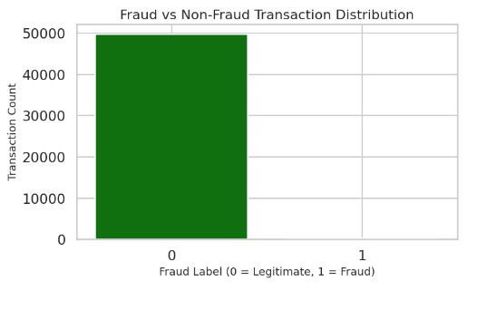
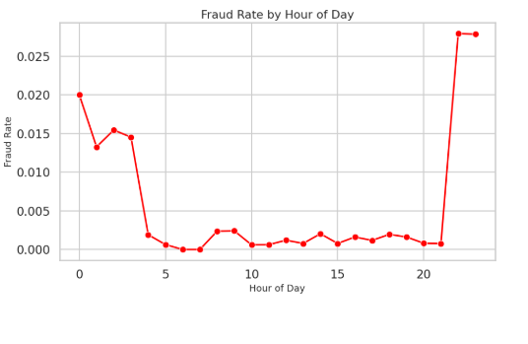
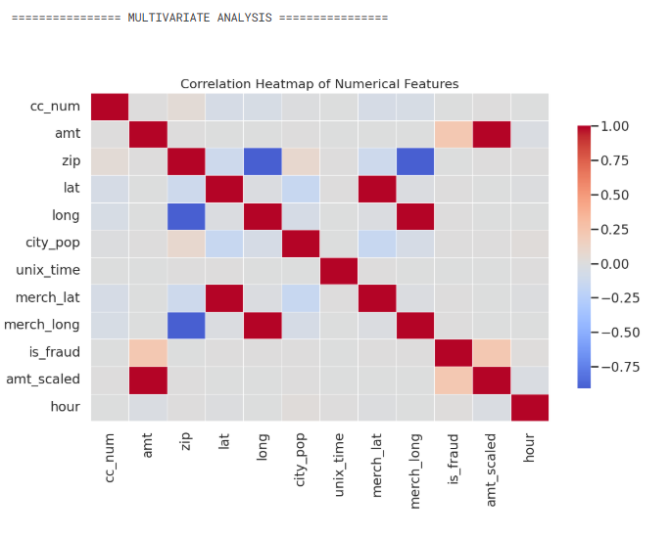
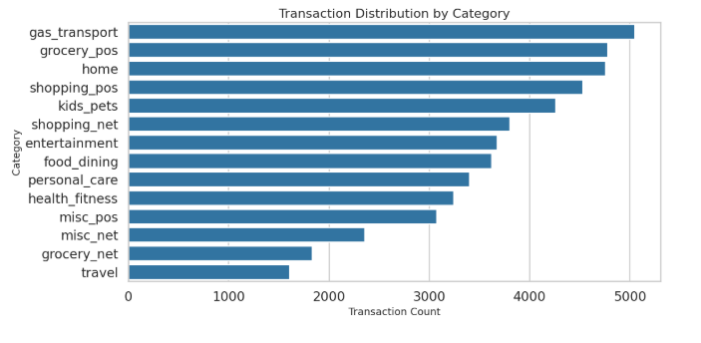
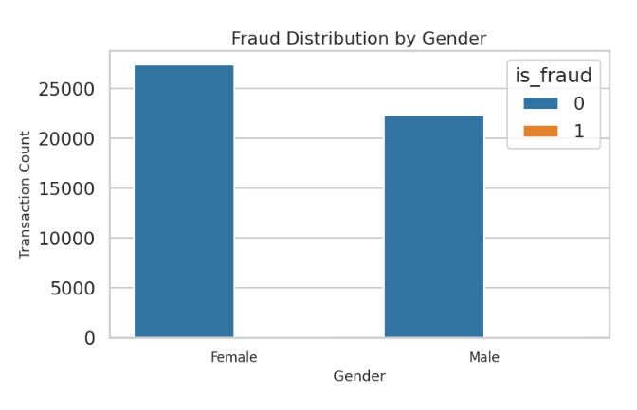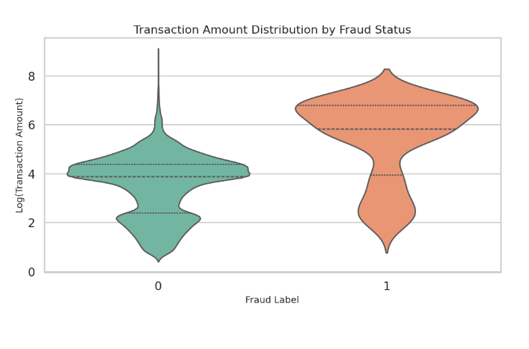
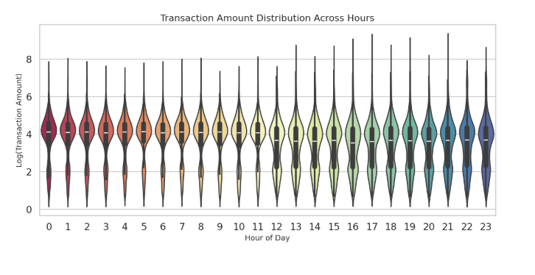
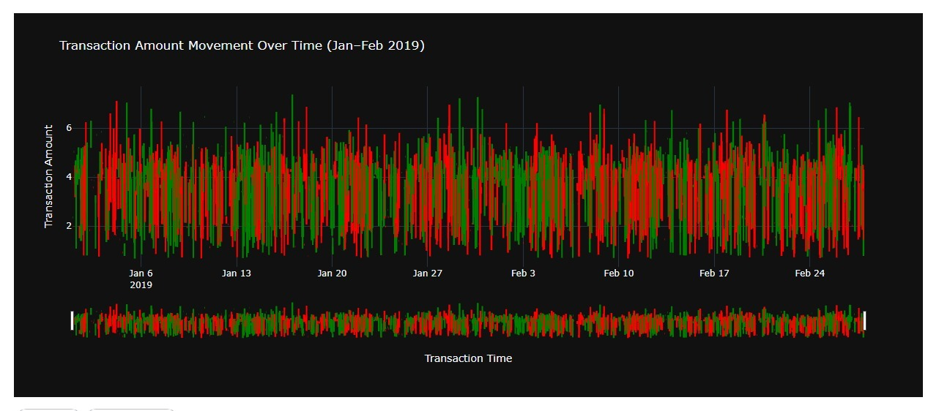
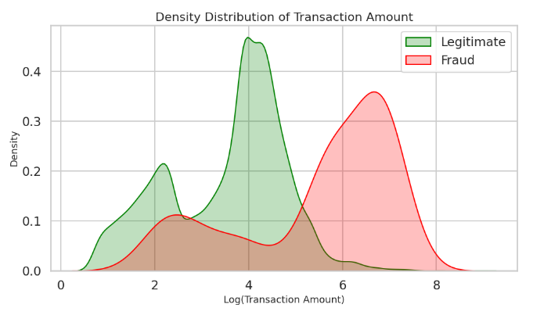

INTERPRETATION:
• Exploratory Data Analysis (EDA) was conducted to understand the distribution and patterns in the transaction dataset using univariate, bivariate, and multivariate techniques.
• The transaction amount (log scale) shows a right-skewed distribution, indicating most transactions are low-value with a few high-value outliers.
• Boxplot analysis confirms the presence of extreme outliers, representing unusually large transactions.
• Transaction frequency varies by hour, showing peak activity at certain times and low activity during late hours.
• Fraud analysis reveals that fraudulent transactions generally have higher amounts and greater variability compared to legitimate ones.
• The dataset is highly imbalanced, with very few fraud cases compared to non-fraud cases.
• Fraud rate varies across hours, indicating that time is an important factor in detecting fraud.
• Correlation analysis shows low relationships between features, reducing multicollinearity issues.
• Visualization techniques like violin plots and KDE plots indicate that fraud transactions are more spread out and tend to have higher values.
• The candlestick plot shows transaction amount fluctuations over time, helping identify trends and unusual spikes.
• Overall, transaction amount and time are key indicators, and the dataset is suitable for further modeling and fraud detection analysis.

TEAM CONTRIBUTION:

TEAM MEMBER | CONTRIBUTION
DIVYADHARSHINI S | Performed univariate analysis and created distribution plots, histograms, and boxplots to understand transaction amount patterns.
JOHIYA SRI S | Generated bivariate visualizations such as scatter plots and count plots, and analyzed the relationship between transaction amount, fraud, and time.
KARTHIK SARAVANAKUMAR M | Conducted multivariate analysis using correlation heatmaps, violin plots, and category-based analysis to identify patterns and feature relationships.
ARUN P R | Developed the candlestick visualization and analyzed transaction trends over time, and reviewed all EDA results for accuracy and interpretation.

REFERENCES:
http://kaggle.com/code/youssefelbadry10/credit-card-fraud-detection

WEEK 6:
FEATURE ENGINEERING
OBJECTIVE:
To perform feature engineering by applying normalization and scaling techniques to numerical data, encoding categorical variables into suitable numerical formats, and handling skewness in data distribution to improve data quality and enhance the performance of machine learning models.
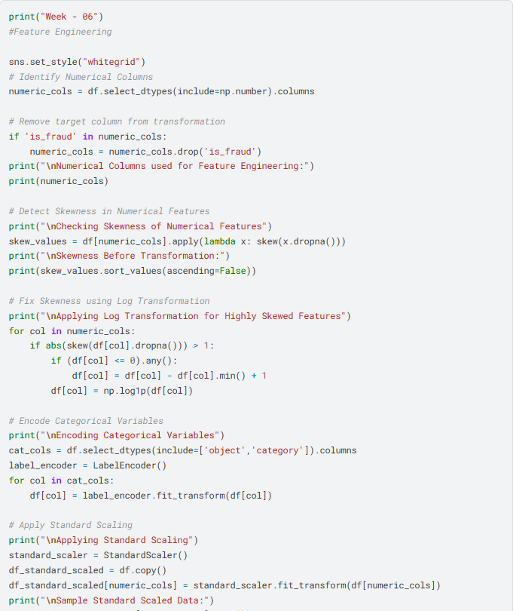

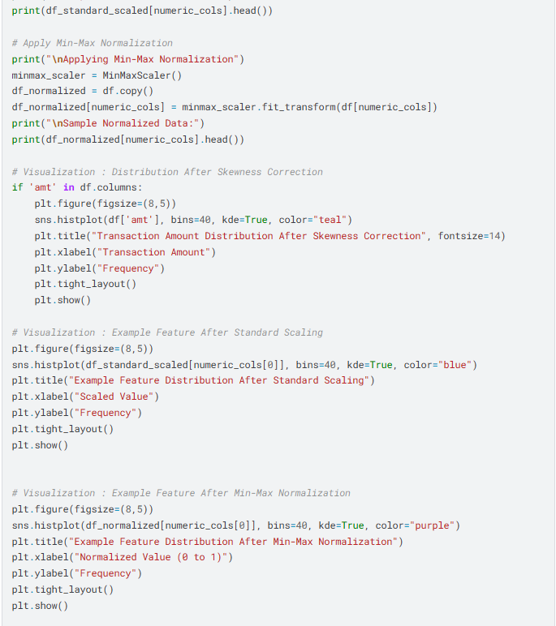
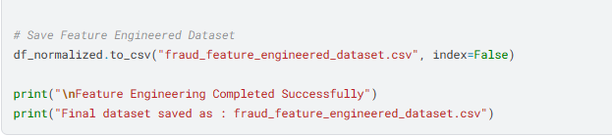

OUTPUT:
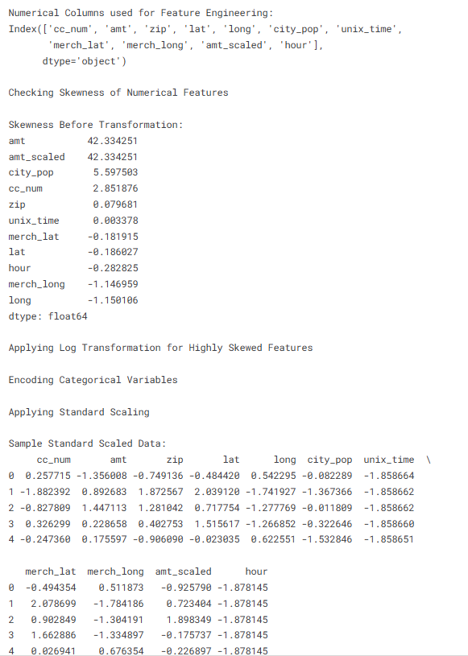
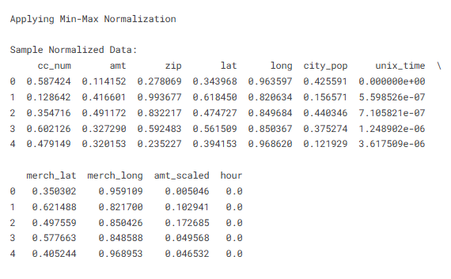

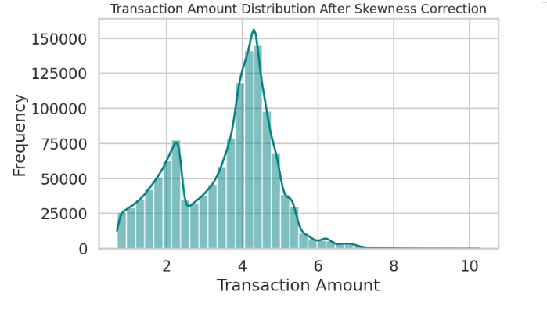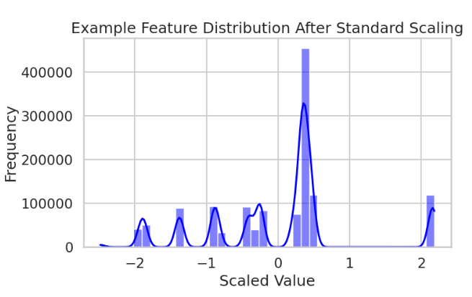

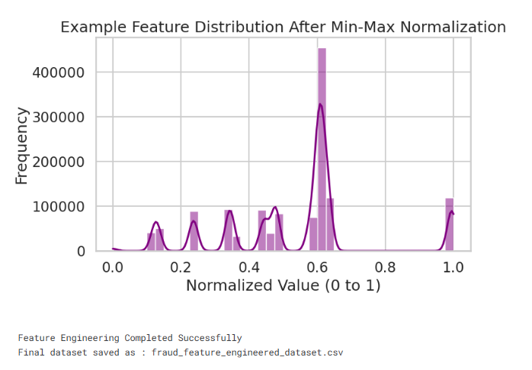
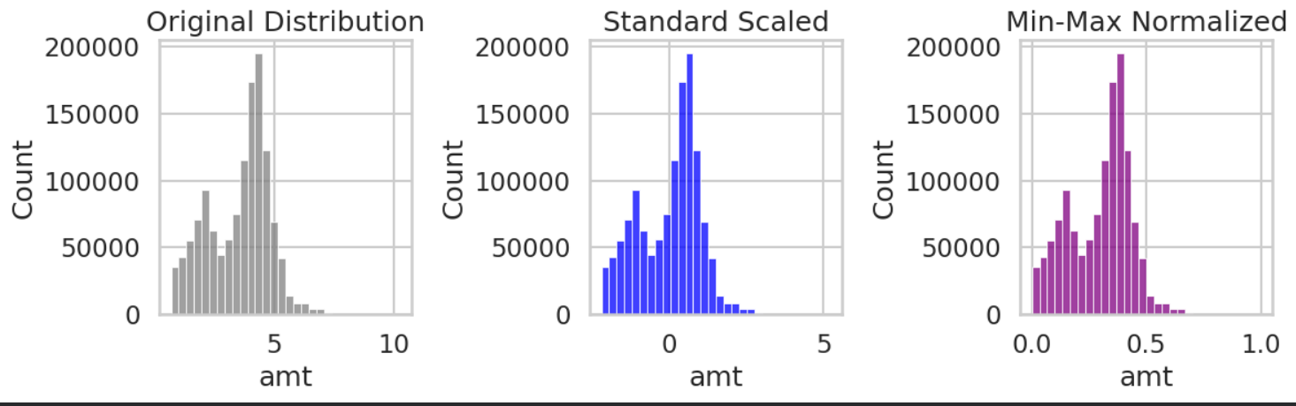
INTERPRETATION:
• Feature engineering was performed to improve data quality by transforming numerical and categorical variables for better model performance.
• Skewness analysis revealed that several numerical features were highly skewed, indicating an uneven distribution of values.
• Log transformation was applied to highly skewed features, which helped in reducing skewness and making the data more normally distributed.
• Categorical variables were encoded using label encoding, converting non-numeric data into machine-readable numerical form.
• Standard scaling was applied to normalize features with mean 0 and standard deviation 1, ensuring that all features contribute equally to the model.
• Min-Max normalization scaled the data into a fixed range (0 to 1), preserving the relative differences between values.
• The histogram after skewness correction shows a more balanced and symmetric distribution, indicating successful transformation.
• The distribution after standard scaling shows values centered around zero, confirming proper standardization.
• The normalized feature distribution demonstrates that all values are bounded within the range of 0 to 1, making it suitable for algorithms sensitive to scale.
• Overall, feature engineering improved the dataset by reducing skewness, standardizing feature scales, and encoding categorical data, making it ready for machine learning model development.

TEAM CONTRIBUTION:

TEAM MEMBER | CONTRIBUTION
DIVYADHARSHINI S | Identified numerical features, analyzed skewness, and applied log transformation to reduce data skewness.
JOHIYA SRI S | Performed encoding of categorical variables and generated visualizations to analyze feature distributions after transformation.
KARTHIK SARAVANAKUMAR M | Applied Standard Scaling and Min-Max Normalization techniques and compared their effects on the dataset.
ARUN P R | Verified the transformed dataset, reviewed feature engineering steps.
REFERENCES:
https://www.kaggle.com/code/minanabil11111212/credit-card-fraud-detection
WEEK 7:
DIMENSIONALITY REDUCTION
OBJECTIVE:
To perform dimensionality reduction by applying feature selection techniques and Principal Component Analysis (PCA) in order to reduce the number of features, eliminate redundancy, and retain maximum variance in the dataset, thereby improving model efficiency and visualization of data patterns.
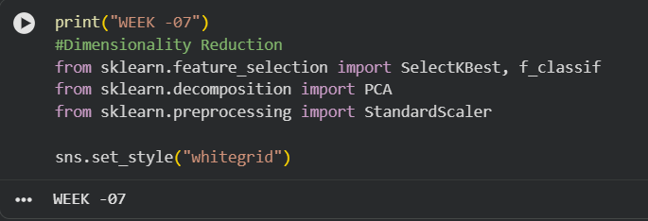
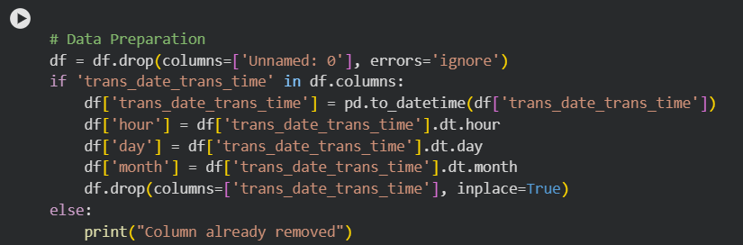
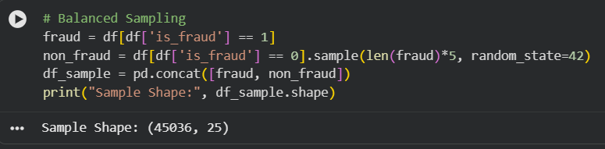
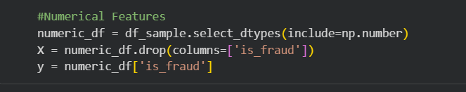
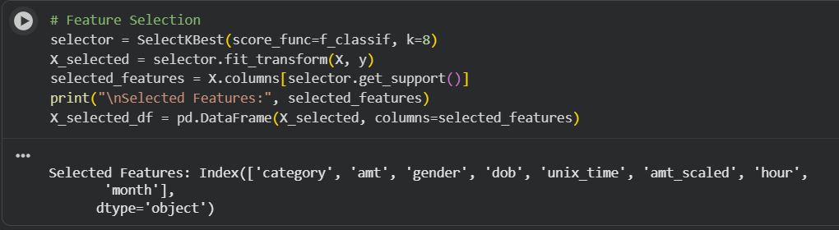
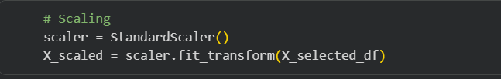
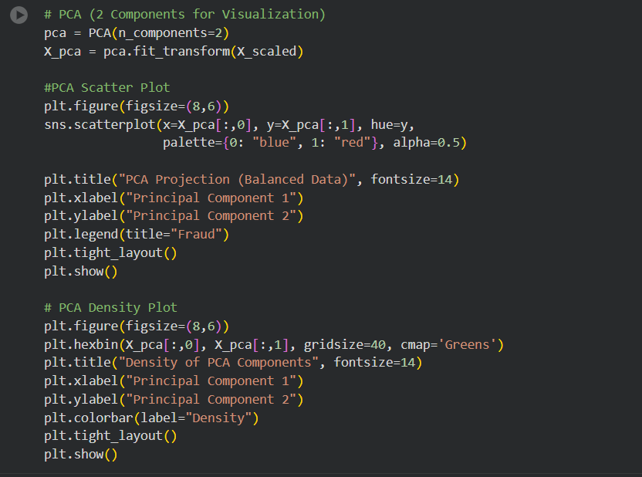

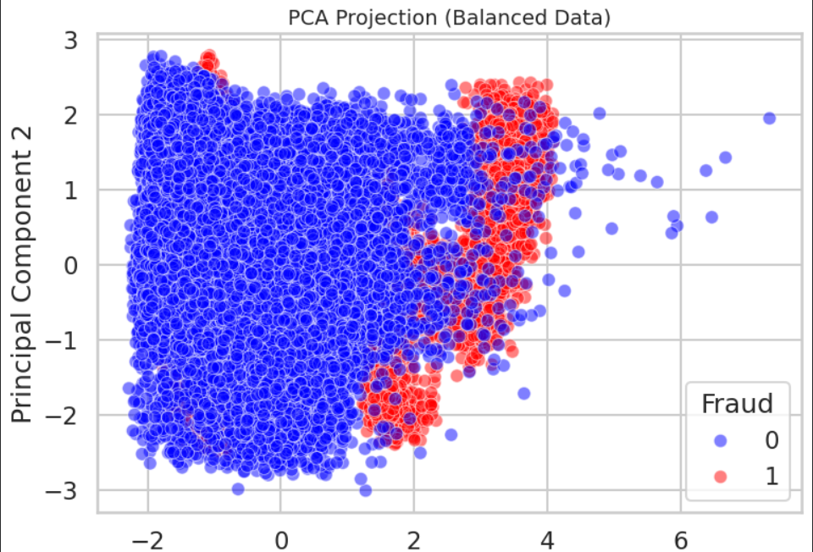
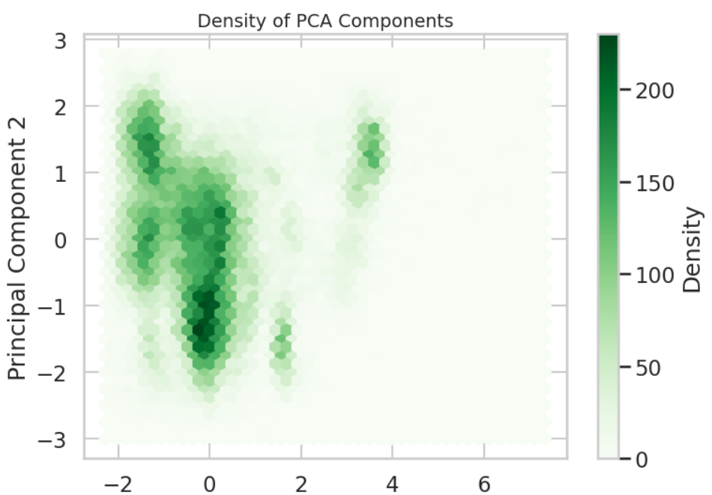

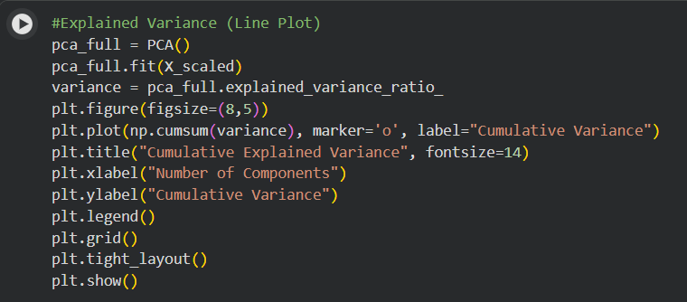
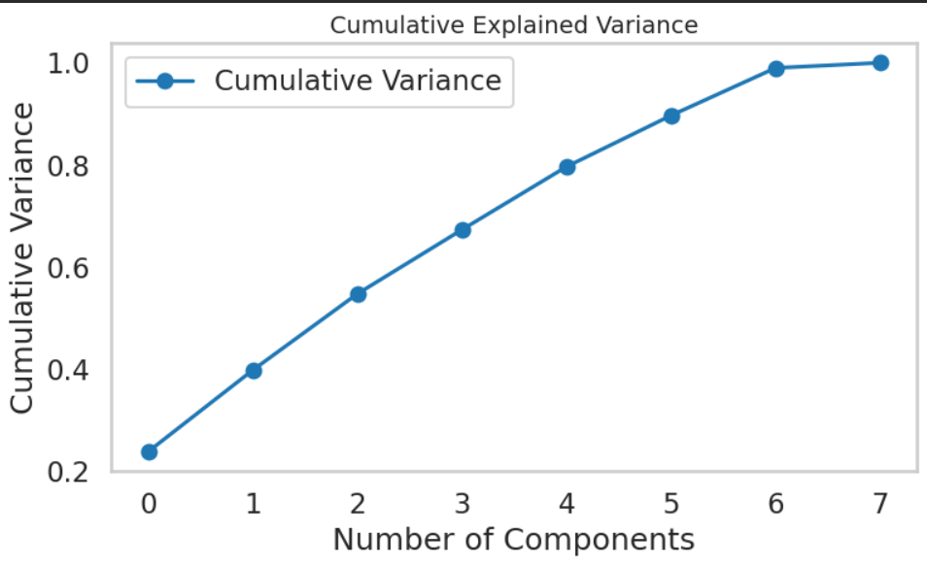
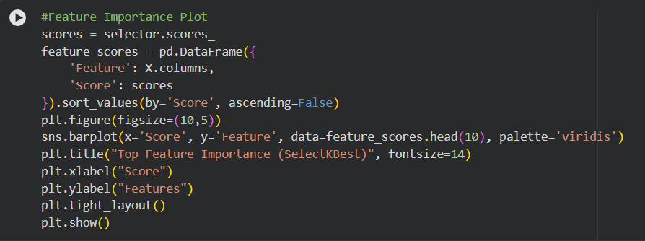
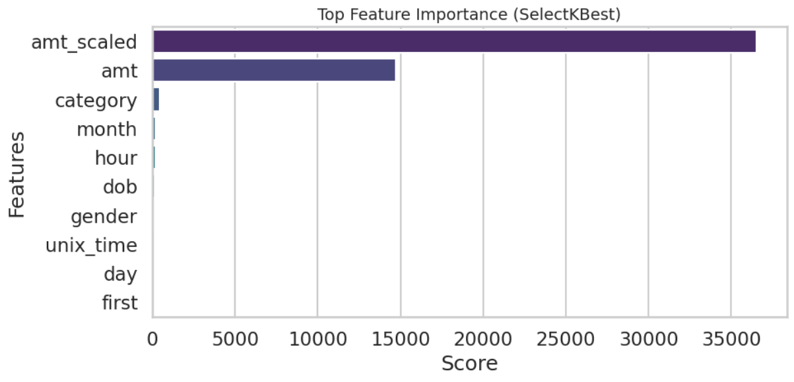
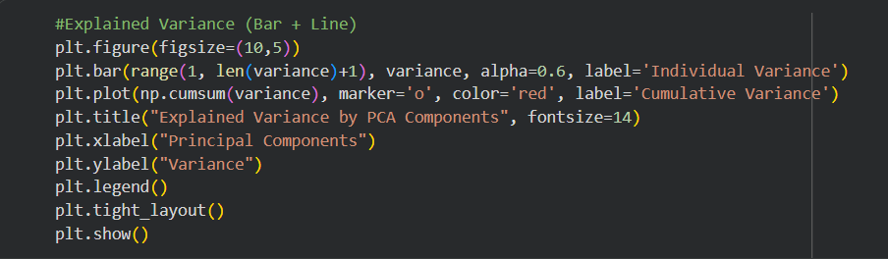
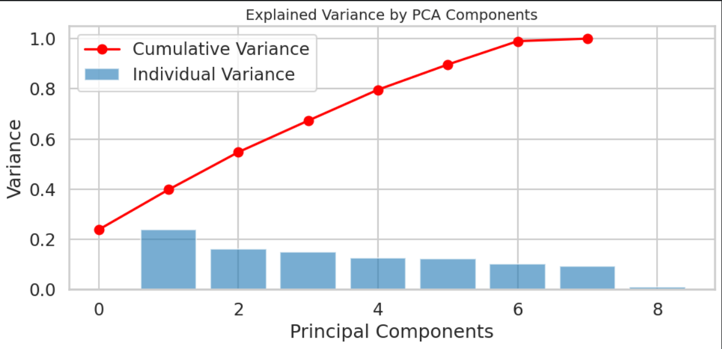
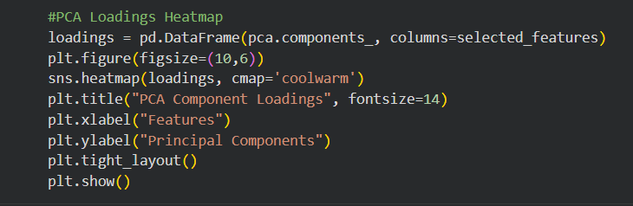
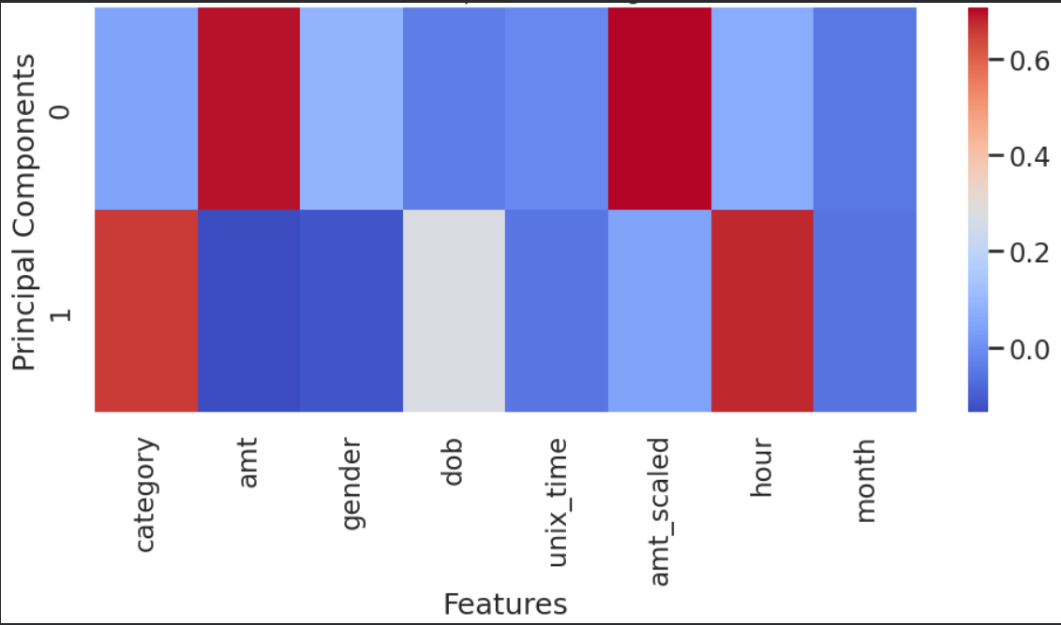
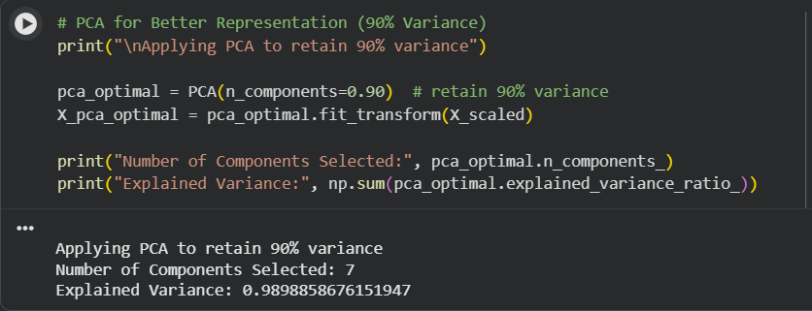
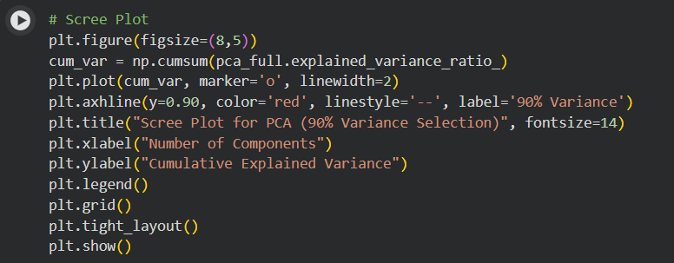
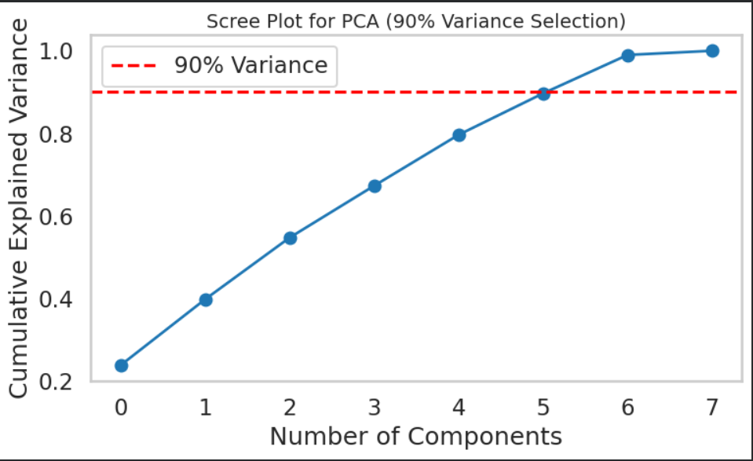
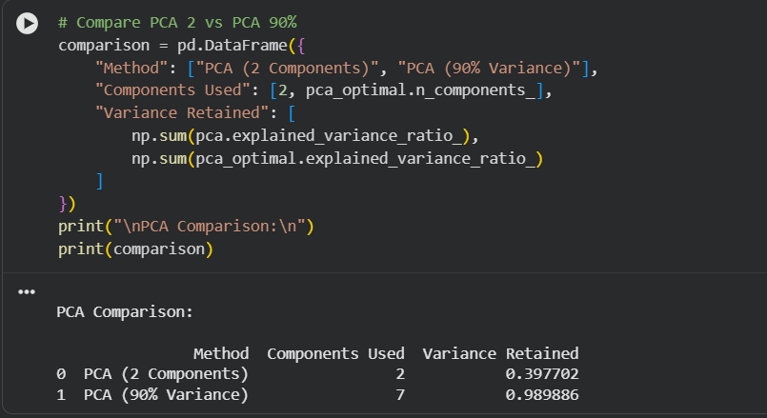
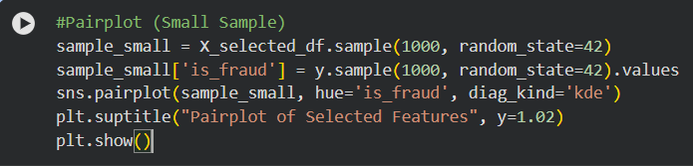
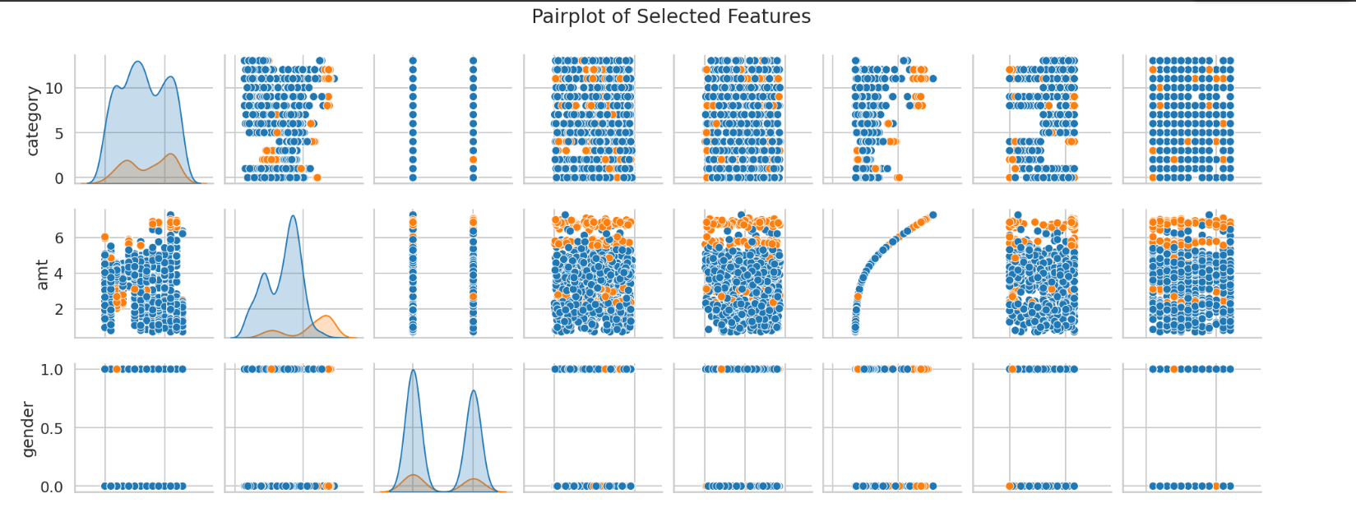
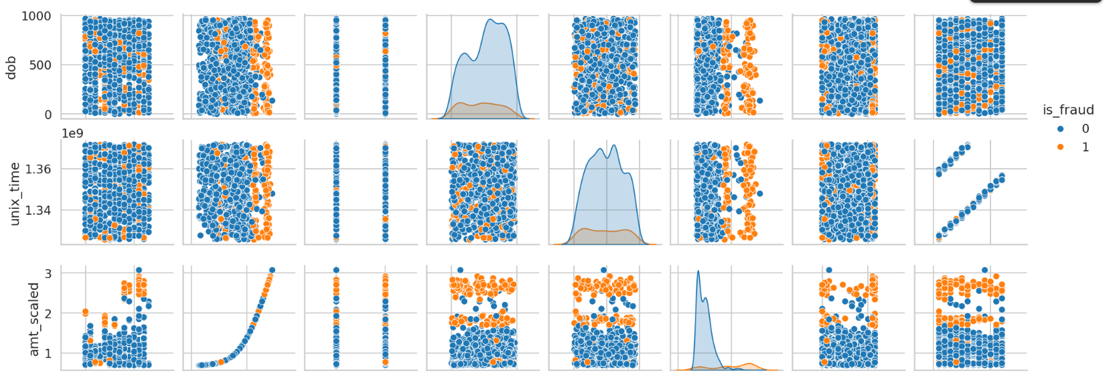
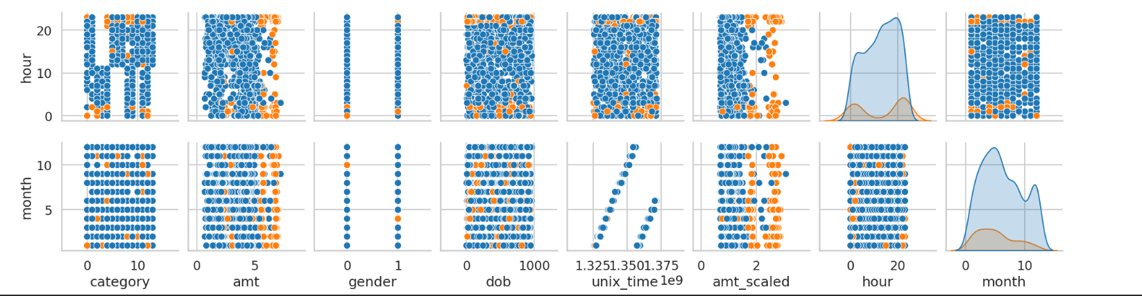
INTERPRETATION:
- First, the dataset was prepared by removing unnecessary columns and extracting useful time-based features such as hour, day, and month from the transaction timestamp. This helped in capturing important temporal patterns in the data.

- Next, only numerical features were selected for dimensionality reduction, and the target variable (is_fraud) was separated. Feature selection was performed using the SelectKBest method, which identified the most important features based on statistical significance. This reduced the number of features while retaining the most relevant information.

- After selecting the important features, standard scaling was applied to ensure that all features were on a similar scale. This step is important because dimensionality reduction techniques like PCA are sensitive to differences in feature magnitude.

- Principal Component Analysis (PCA) was then applied to transform the selected features into a smaller set of components. These components capture the maximum variance in the data, allowing the dataset to be represented in fewer dimensions while preserving important patterns.

- Various visualizations such as scatter plots, density plots, and explained variance graphs were used to analyze the transformed data. These plots helped in understanding how well the data is distributed in reduced dimensions and how much information is retained by the principal components.

TEAM CONTRIBUTION:
TEAM MEMBER | CONTRIBUTION
DIVYADHARSHINI S | Performed feature selection by identifying important features and removing irrelevant or redundant variables.
JOHIYA SRI S | Implemented PCA and generated visualizations to analyze variance and reduced feature space.
KARTHIK SARAVANAKUMAR M | Analyzed explained variance ratio and determined the optimal number of principal components.
ARUN P R | Reviewed dimensionality reduction results and verified the effectiveness of feature selection and PCA for model improvement.
REFERENCES:
https://www.kaggle.com/code/satyajeetrai/credit-card-fraud-detection
WEEK 8:
DASHBOARD CONSTRUCTION
OBJECTIVE:
To construct an interactive dashboard using Power BI by integrating multiple visualizations into a cohesive narrative, enabling effective data storytelling, improved user interaction, and clear interpretation of insights for better decision-making.

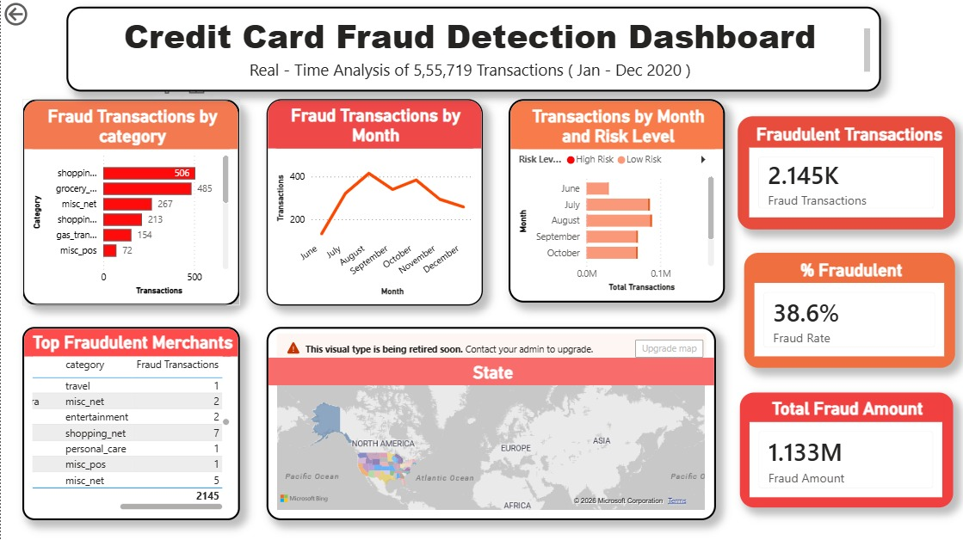

INTERPRETATION:
• The dashboard provides a comprehensive overview of credit card fraud transactions, analyzing over 555,719 transactions from Jan–Dec 2020.
• The total number of fraudulent transactions is 2.145K, with a fraud rate of 38.6%, indicating a significant presence of fraud in the dataset.
• The total fraud amount is approximately 1.133 million, showing that fraudulent activities involve a considerable financial impact.
• Category-wise analysis shows that shopping and grocery-related transactions have the highest number of fraud cases, indicating these categories are more vulnerable.
• The monthly trend of fraud transactions shows fluctuations over time, with certain months experiencing higher fraud activity, suggesting seasonal or behavioral patterns.
• Transactions categorized by risk level indicate that a larger portion falls under high-risk transactions, highlighting potential areas of concern.
• The top fraudulent merchants analysis identifies specific categories like travel, entertainment, and shopping where fraud frequently occurs.
• The geographical (state-wise) visualization shows that fraud is spread across multiple regions, with some areas having higher concentrations.
• Overall, the dashboard effectively highlights fraud patterns based on category, time, risk level, and location, helping in better understanding and detection of fraudulent activities.
TEAM CONTRIBUTION:
TEAM MEMBER | CONTRIBUTION
DIVYADHARSHINI S | Assisted in organizing the final dataset and supported report preparation related to dashboard insights and findings.
JOHIYA SRI S | Designed dashboard visuals and contributed to structuring the layout for clear data storytelling and interpretation.
KARTHIK SARAVANAKUMAR M | Developed the Power BI dashboard by integrating multiple visualizations and implementing filters for user interaction.
ARUN P R | Reviewed the dashboard, finalized presentation (PPT), and ensured all components were properly integrated and accurate.

